Project Design Phase-II
Data Flow Diagram & User Stories

Date | 28-11-2025
Team ID
Project Name | Flight Booking System
Maximum Marks | 4 Marks

Data Flow Diagrams:
A Data Flow Diagram (DFD) illustrates how data moves within the Flight Booking System platform.
It explains how users (Passengers, Admins, and Airlines) interact with the system, how flight information flows between components, and where booking and passenger data are stored.

DFD Level 0 – Flight Booking System
The DFD Level 0 (Diagram) of the Flight Booking System provides a high-level overview of how data flows between the system and its external entities. It represents the entire system as a single unified process and shows how passengers, admins, and airline systems exchange information with it.

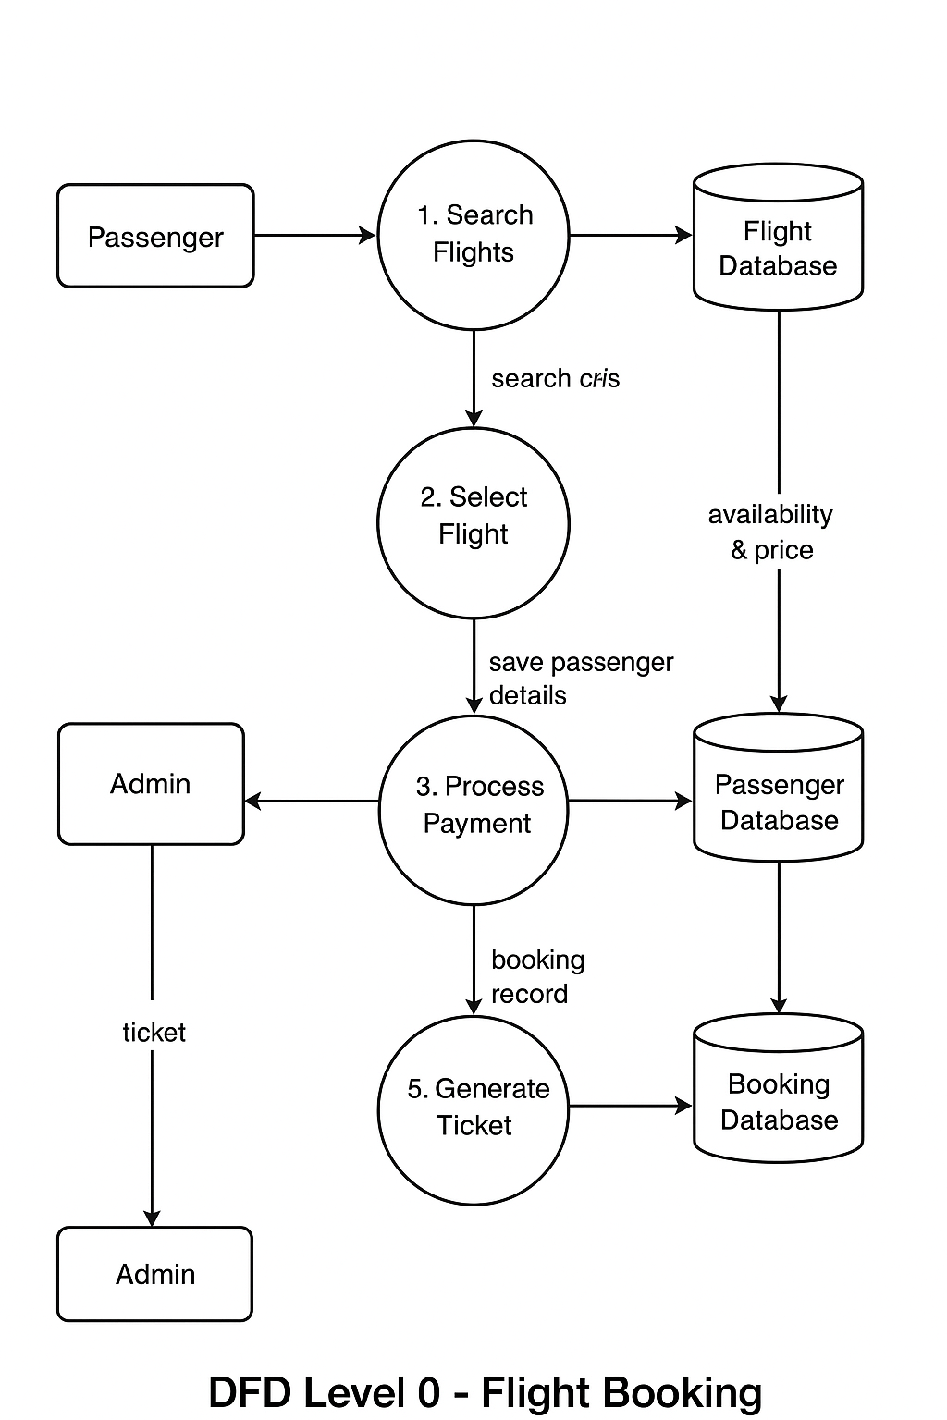
User Stories– Flight Booking System
User Type | Functional Requirement | User Story / Task | Acceptance Criteria | Priority | Release
Passenger | Flight Search | As a passenger, I can search for flights using date, origin, destination, and passenger count. | The system returns accurate flight results matching the search filters. | High | Sprint-1
Passenger | Flight Selection | As a passenger, I can select a flight and view fare, airline, timings, and seat availability. | Selected flight loads correct details and availability. | High | Sprint-1
Passenger | Passenger Details & Seat Selection | As a passenger, I can enter traveler details and choose preferred seats. | Traveler data saved and seat map loads correctly. | Medium | Sprint-2
Passenger | Booking & Payment | As a passenger, I can make a secure online payment to confirm the booking. | Payment successfully and PNR/ticket generated. | High | Sprint-2
Passenger | Booking History | As a passenger, I can view all my previous bookings. | Booking history displays correct past ticket data. | Low | Sprint-3
Admin | Flight Management | As an admin, I can add, edit, or remove flight schedules, pricing, and availability. | Updates reflect instantly across the system. | High | Sprint-1
Admin | Booking Monitoring | As an admin, I can view all bookings made by passengers. | Admin dashboard displays complete and accurate booking data. | Medium | Sprint-2
Admin | User Management | As an admin, I can manage passenger accounts and resolve issues. | User profiles updated and issued logs recorded successfully. | Medium | Sprint-3
Airline System | Real-time Flight Info | As an airline system, I can provide availability, fare, and schedule information to the platform. | The platform receives accurate real-time flight and fare data. | High | Sprint-1

